EXPERIMENT 8-APPLICATION OF DIFFERENTIAL EQUATION IN GAME THEORY

AIM:

TO STUDY ABOUT HOW SOLVING DIFFERENTIAL EQUATION IS USEFUL IN THE FIELD OF GAME THEORY IN COMPUTER SCIENCE

MATHEMATICAL BAKGROUND:

In today’s world we see a lot of games being developed.Some are simple games like Mario,dave and other very complex like GTA,Clash of Clans,Age of empires.But in all these games,there is a situation where the user controls the character and the computer responds according to the input given by user.To calculate the response to the set of inputs given by the user,differential equation is used.For example when a user wants to make a character jump and run,it is necessary to calculate at what position the character needs to land after the jump occurs.For this ,the solution of the equation,

https://qph.is.quoracdn.net/main-qimg-308127cb7401bd87952d85885cff21dc?convert_to_webp=true

gives the position required.Here P is the position of the character and g is acceleration downwards.The value of g is arbitrary .The game developer can choose any value.

MATHEMATICAL BACKGROUND:

The [Laplace transform](https://en.wikipedia.org/wiki/Laplace_transform) is a powerful [integral transform](https://en.wikipedia.org/wiki/Integral_transform) used to switch a function from the [time domain](https://en.wikipedia.org/wiki/Time_domain) to the [s-domain](https://en.wikipedia.org/wiki/Laplace_transform#s-Domain_equivalent_circuits_and_impedances). The Laplace transform can be used in some cases to solve [linear differential equations](https://en.wikipedia.org/wiki/Linear_differential_equation) with given [initial conditions](https://en.wikipedia.org/wiki/Initial_value_problem).

First consider the following property of the Laplace transform:

\mathcal{L}\{f'\}=s\mathcal{L}\{f\}-f(0)

\mathcal{L}\{f''\}=s^2\mathcal{L}\{f\}-sf(0)-f'(0)

One can prove by [induction](https://en.wikipedia.org/wiki/Mathematical_induction) that

\mathcal{L}\{f^{(n)}\}=s^n\mathcal{L}\{f\}-\sum_{i=1}^{n}s^{n-i}f^{(i-1)}(0)

Now we consider the following differential equation:

\sum_{i=0}^{n}a_if^{(i)}(t)=\phi(t)

with given initial conditions

f^{(i)}(0)=c_i

Using the [linearity](https://en.wikipedia.org/wiki/Linearity) of the Laplace transform it is equivalent to rewrite the equation as

\sum_{i=0}^{n}a_i\mathcal{L}\{f^{(i)}(t)\}=\mathcal{L}\{\phi(t)\}

obtaining

\mathcal{L}\{f(t)\}\sum_{i=0}^{n}a_is^i-\sum_{i=1}^{n}\sum_{j=1}^{i}a_is^{i-j}f^{(j-1)}(0)=\mathcal{L}\{\phi(t)\}

Solving the equation for  \mathcal{L}\{f(t)\} and substituting f^{(i)}(0) with c_i one obtains

\mathcal{L}\{f(t)\}=\frac{\mathcal{L}\{\phi(t)\}+\sum_{i=1}^{n}\sum_{j=1}^{i}a_is^{i-j}c_{j-1}}{\sum_{i=0}^{n}a_is^i}

The solution for *f*(*t*) is obtained by applying the [inverse Laplace transform](https://en.wikipedia.org/wiki/Inverse_Laplace_transform) to \mathcal{L}\{f(t)\}.

Note that if the initial conditions are all zero, i.e.

f^{(i)}(0)=c_i=0\quad\forall i\in\{0,1,2,...\ n\}

then the formula simplifies to

f(t)=\mathcal{L}^{-1}\left\{{\mathcal{L}\{\phi(t)\}\over\sum_{i=0}^{n}a_is^i}\right\}

MATLAB CODE:

clc

clear all

syms x s y eq LTY k

y2=diff(sym('y(x)'),2);

y0=sym('y(x)');

g=input('Enter value of g');

eqn=g\*y2-0;

LYT=laplace(eqn,x,s);

a=input('Enter y(0)');

LYT=subs(LYT,{'laplace(y(x),x,s)','y(0)'});

eq=collect(LTY,y);

y=simplify(solve(eq,y));

k=simplify(ilaplace(y,s,x))

OUTPUT: 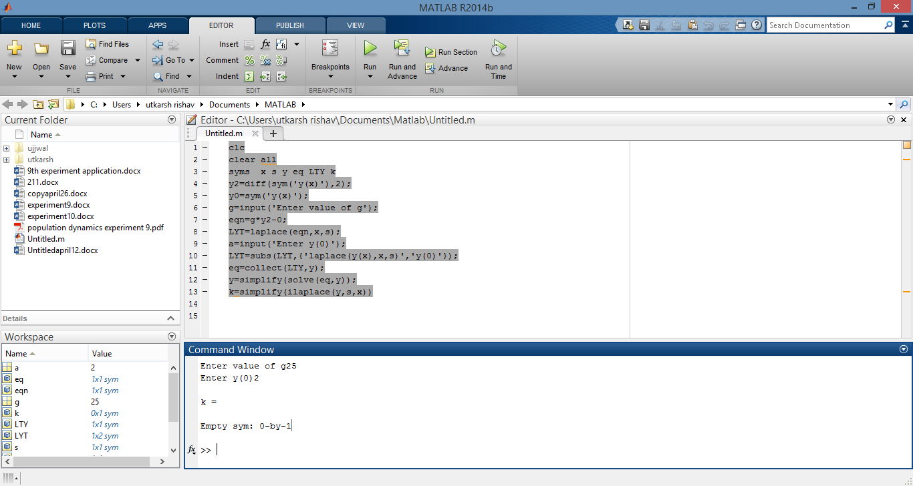

ENGINEERING INTERPRETATION:

Differential equation is definitely an important part in games.Apart from jumping and moving,it is also used to do many other movements like shooting a gun(where bullet position is calculated on the basis of differential equations),driving a car(car’s position based on acceleration and deceleration is calculated by differential equations),running,etc.In each and very case,there are different differential equations and different constraints, and in each and every case the final output is finding the new position of the object.One can also use them for complex movements like fighting etc. where a lot of differential equations are required to be solved simultaneously.Wherever there is physics of motion involved,there is differential equation .